K MEANS CLUSTERING REPORT
K means clustering is a popular and widely used unsupervised machine learning algorithm. Its main objective is to partition the data into a specific number (k) of groups, where data points within each group are similar and dissimilar to points in other groups. In another words, it is an iterative process of assigning each data point to the groups and slowly the data points get clustered based on similar features. Its primary goal is to ensure that the data points within each cluster are as similar as possible, while the clusters themselves are as different as possible from one another. Its application spans various fields, making it one of the most important tools in the data scientists toolkit.

The steps to optimize the clustering process of k means algorithm would be to initialize as the algorithm start by selecting K initial centroids randomly from the dataset. Centroid is the central point of a cluster, calculated as the meaning of all data points within the cluster. Then each data point is assigned to the nearest centroid, and the distance is usually calculated using Euclidean distance, however, other distance metrics can be used depending on the dataset’s nature. The Euclidean is often the default distance used in k means clustering to find the k closest to a particular sample point. The Euclidean distance can be calculated by d(x, y) = $\sqrt{(x-y)/(x-y)}$.

Moreover, once all the points are assigned to clusters, the centroids are recalculated. The new centroid of a cluster is the meaning of all points in the cluster. The assigned and the update steps are repeated until the centroids stabilize and no longer move significantly, indicating that the clusters are well formed.

There are some key concepts that need to be mentioned. The centroid, inertia and convergence. Since centroid is already discussed, we will talk about the other two. Inertia is a measure of how well the clusters are formed. It is the sum of squared distances from each data point to its assigned centroid. A good model in terms of inertia would be a low inertia and a low number of clusters. The low inertia value means that the more coherent are the different clusters.

Convergence is the point at which centroids do not change significantly with further iterations. This also means that the algorithm has successfully completed this clustering or grouping of data points in k number of clusters.

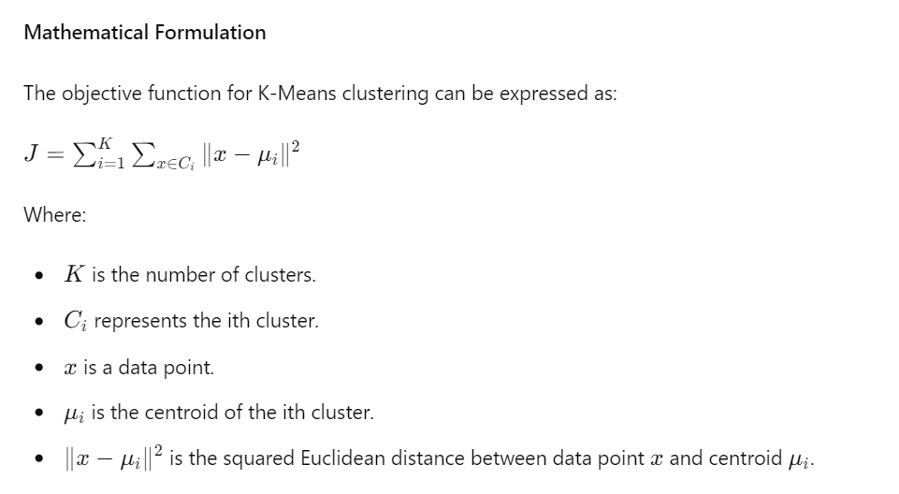

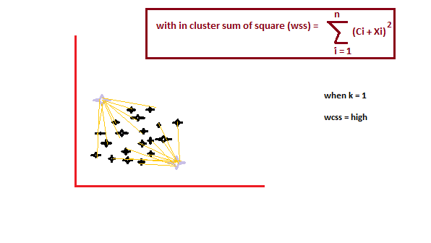

Furthermore, let’s now discuss their applications. K means clustering is utilized in various domains. Market segmentation is where companies use this to segment customers based on purchasing behavior, allowing for targeted marketing strategies.

Image compression is another where k means can reduce the number of colors in an image, thereby compressing it while maintaining visual quality. Document clustering is where k means helps it in organizing a large set of documents into clusters of related topics.

Lastly, anomaly detection, where it effectively identifies outliers in datasets, can be crucial for fraud detection and network security.

The advantages would be that it is easy to understand and implement, computationally efficient and can handle large datasets with high dimensionality. It can handle large datasets with many data points and can be easily scaled to handle even larger datasets. Additionally, it can be easily adapted to different applications and can be used with different distance metrics and initialization methods.

Yet there are some disadvantages also. It is sensitive to the initial selection of centroids and can converge to a suboptimal solution. Another one is that the number of clusters k needs to be specified before running the algorithm, which can be challenging in some applications; and lastly, k means is sensitive to outliers, which can have a significant impact on the resulting clusters.

There are several techniques that can optimize the performance of the k means clustering. Initially, we discussed the elbow method. This method helps determine the optimal number of clusters k. By plotting the inertia against the number of clusters and looking for an elbow point where the rate of decrease sharply changes, one can identify the appropriate k. Then the silhouette score where score measures how similar a data point is to its own cluster compared to other clusters. A higher silhouette score indicates better-defined clusters. Finally, the k means ++. An enhancement over the standard k means algorithm, k means ++ improves the selection of initial centroids, leading to better convergence and cluster formation.

Elbow method:
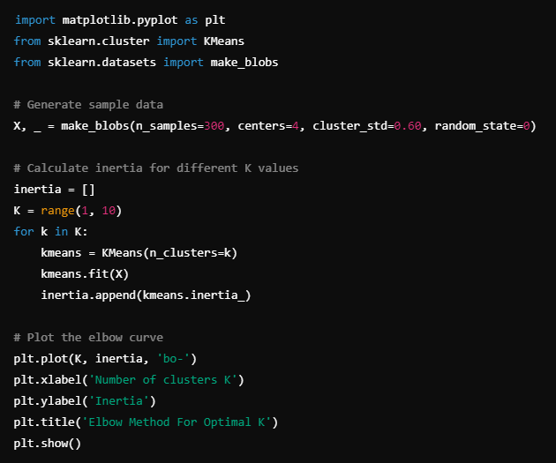

K means ++:
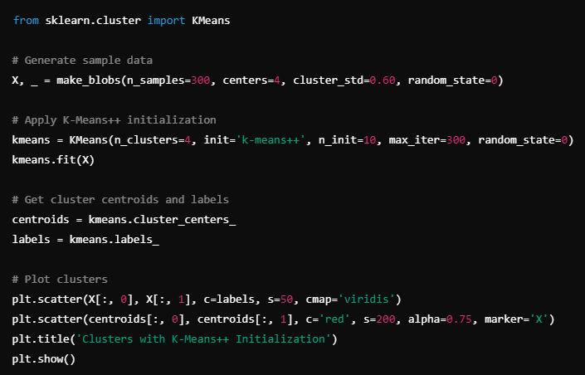

To conclude, k means clustering is an efficient algorithm for partitioning data into clusters. Its simplicity and computational efficiency make it suitable for large datasets. However, it requires careful consideration of the number of clusters and initial centroids. Optimization techniques like the elbow method and k means ++ can enhance its performance. With appropriate tuning, k means can provide valuable insights and patterns in various datasets, making it a powerful tool in data analysis and machine learning.

